PRACTICAL NO. 8
Aim: Merge Sort.
Input
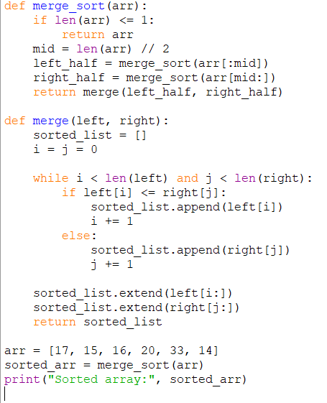
Output
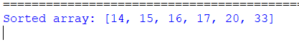

PRACTICAL NO. 9
#Dynamic Programming.
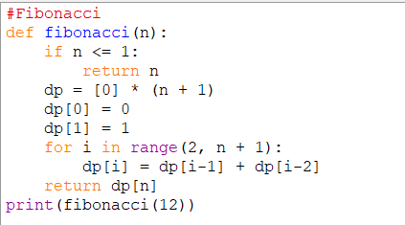
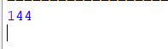
#Largest Common Subsequence (LCS).
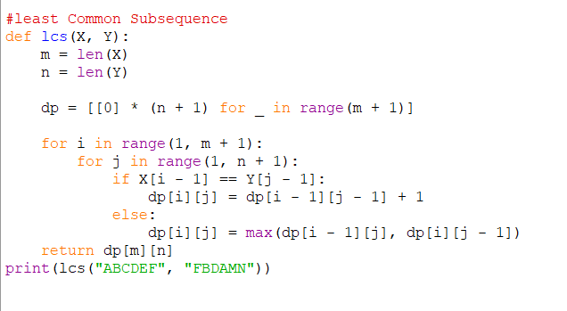
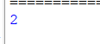

PRACTICAL NO. 10
Aim: Write a program for finding LCM and GCD.
Input
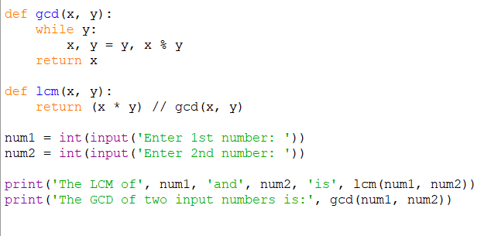
Output
